Help Guide for CBICT-SFX

CBICT-SFX is a secure file transfer system. Once your organisation has been approved to use SFX for its email domain, there is no need for you to submit a formal request to use the system. To register you’ll need to have a valid school email address, and you will need to create a password and a four-digit PIN (Personal Identification Number). Passwords must be at least ten alphanumeric characters long. Please remember these details for future entries or password resets. Once you’ve registered, an email will be sent to the email address you registered with asking you to verify that email address. Once you’ve clicked on the link within the email you’ll be taken back to the SFX web site where you’ll be able to logon.
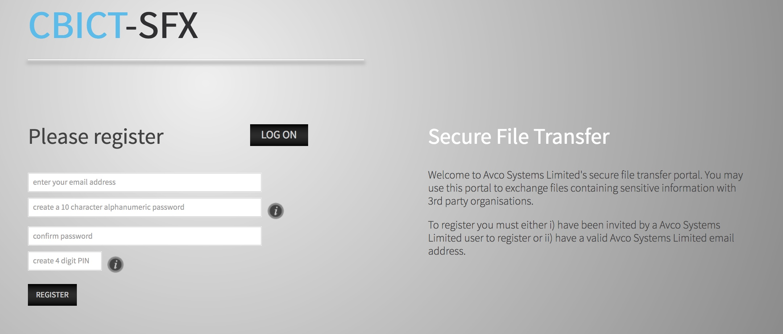
Note: Once registered please add the site to your favourites or create a desktop shortcut.

Log on screen

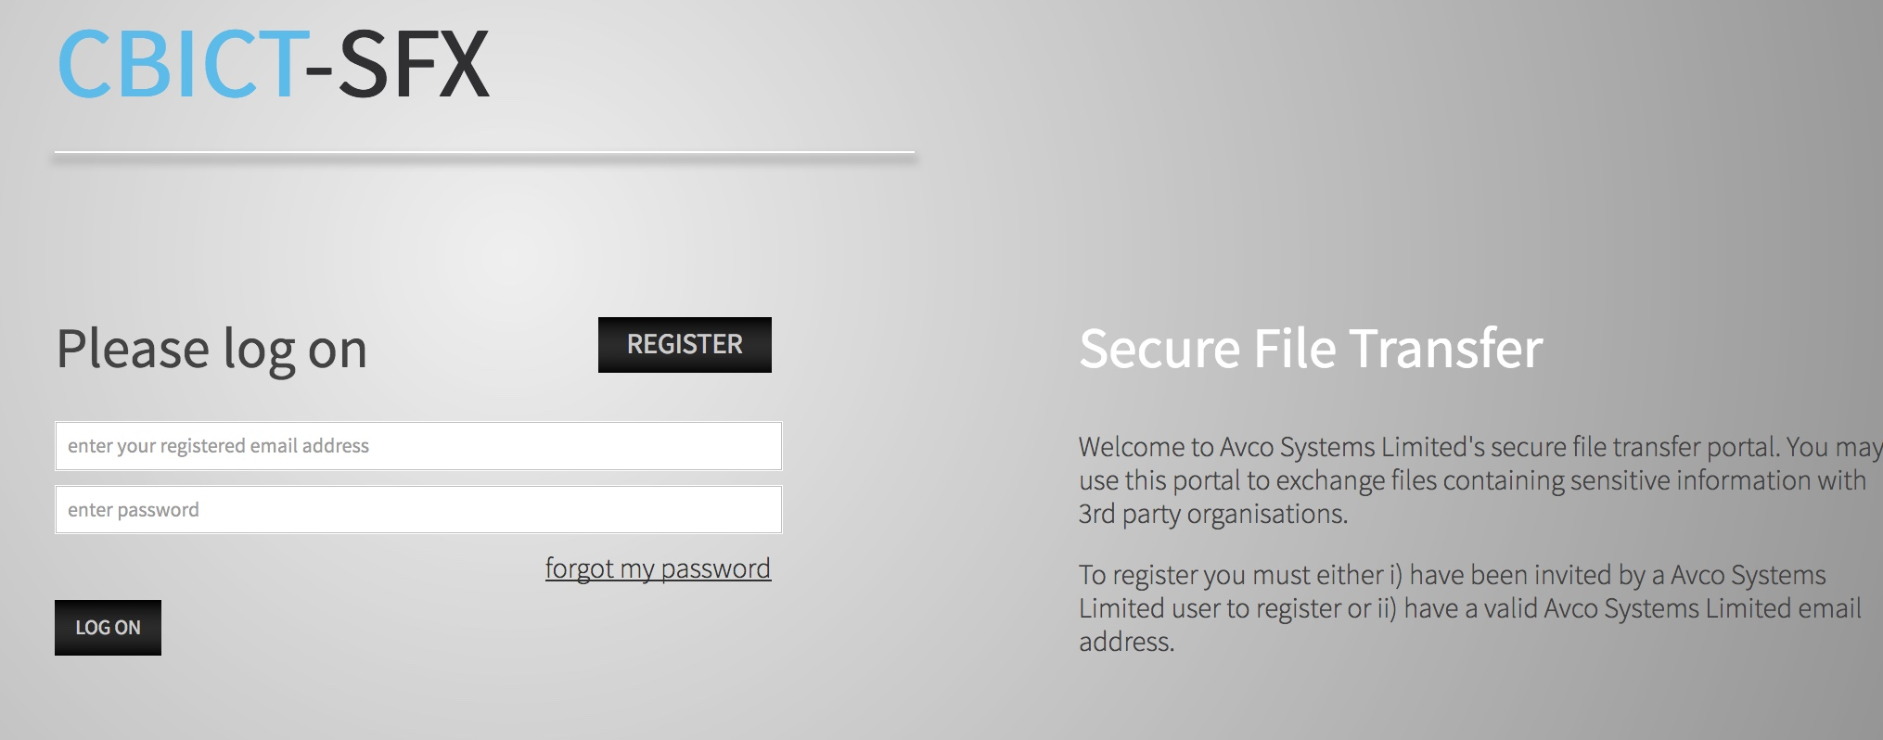

Using the system:
When you are logged on, you will see the following menus.
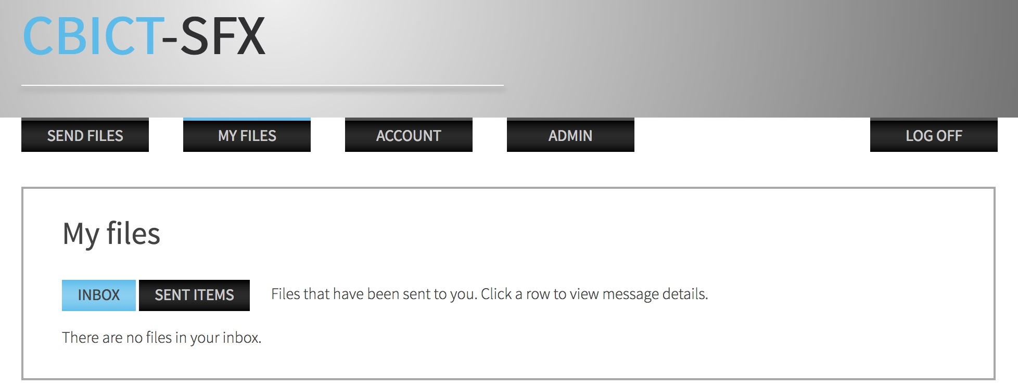

Sending Files and Messages
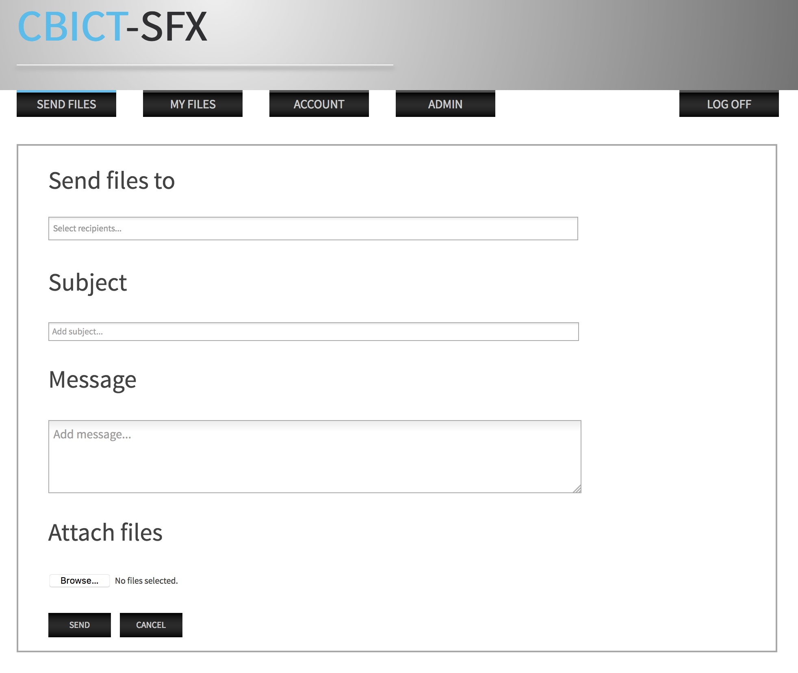
Click on the tab ‘SEND FILES’ and the following screen will appear.

Enter the address of the recipient in the ‘Send files to’ box, then add a subject, then your message (usually this will be referring to the file being sent)
Now click on the browse button in the bottom left and search your hard disc for the correct file and upload it to the system.
Finally click ‘Send’ and your file will be sent to the recipient.
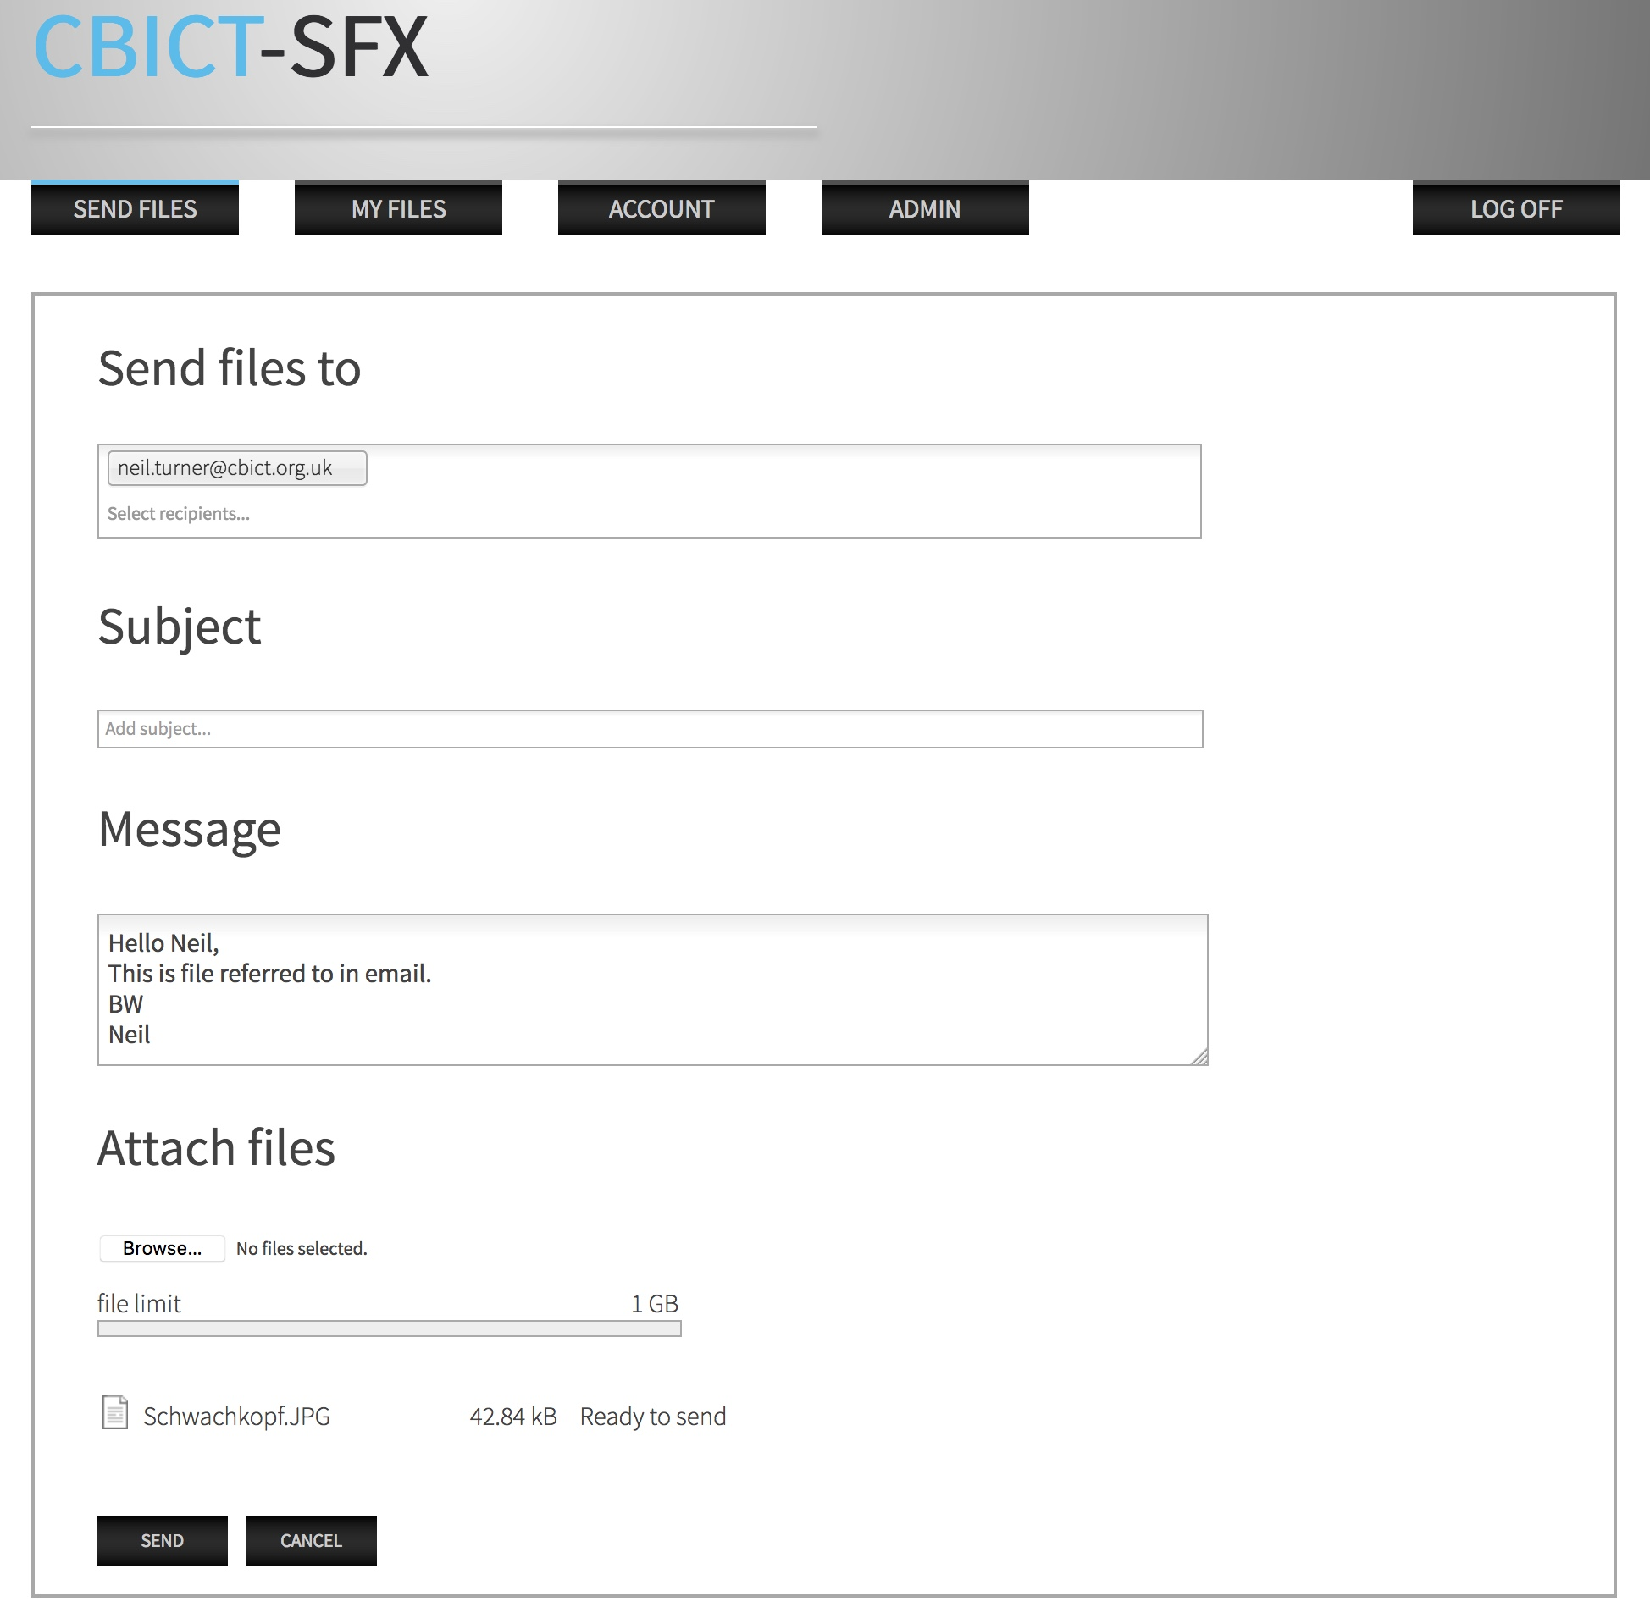

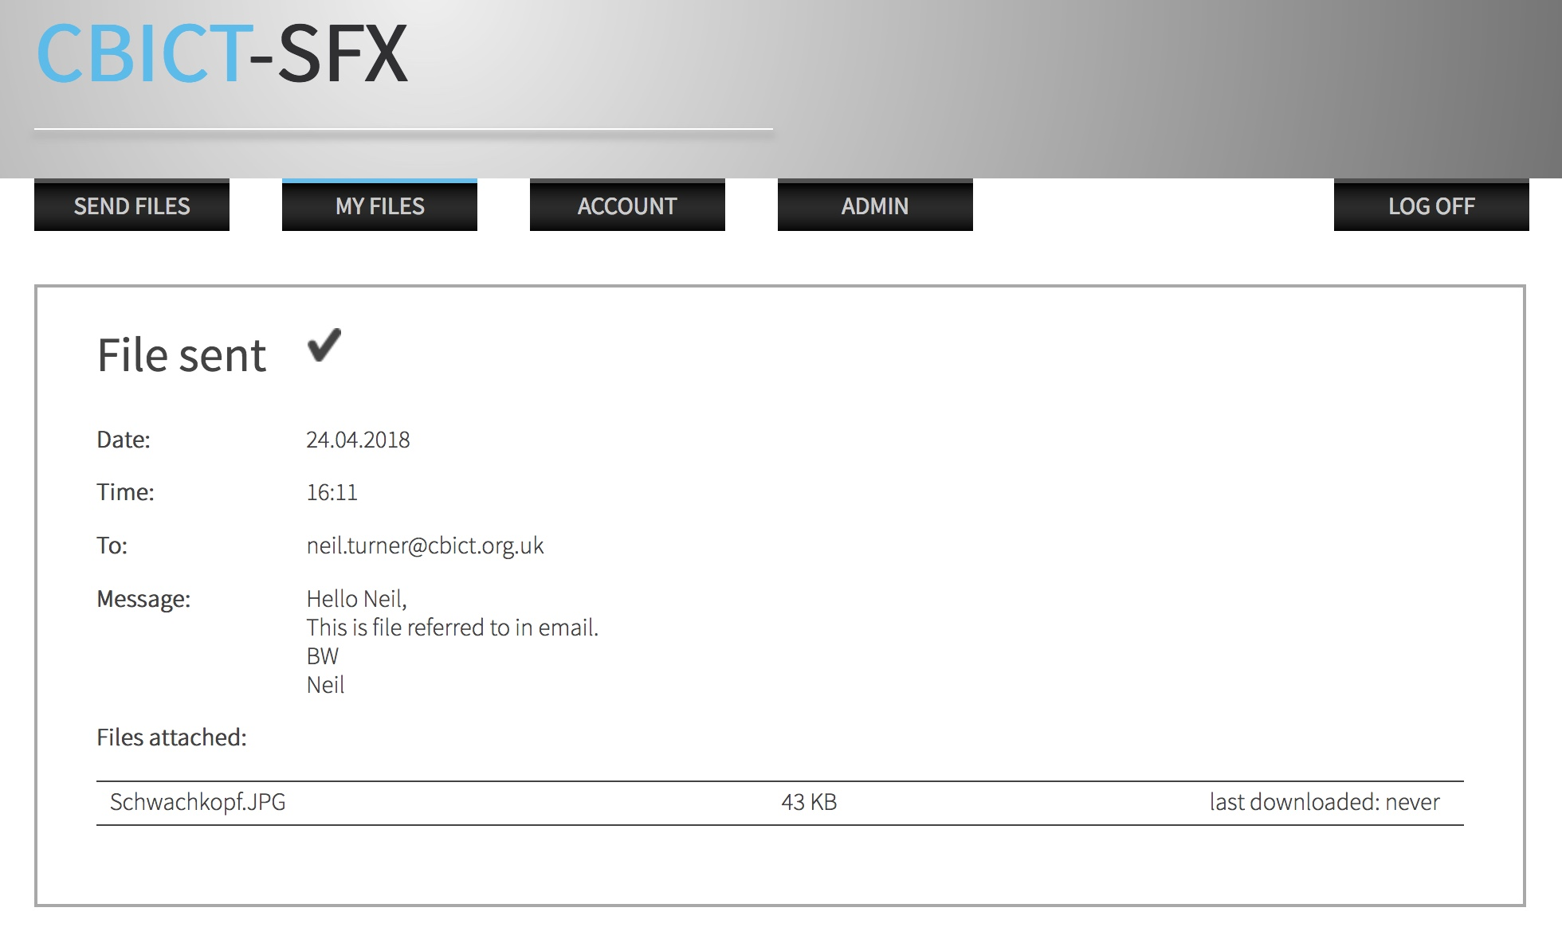
Once the file or files have been uploaded a Report will be displayed:

and a notification email sent to the recipient.
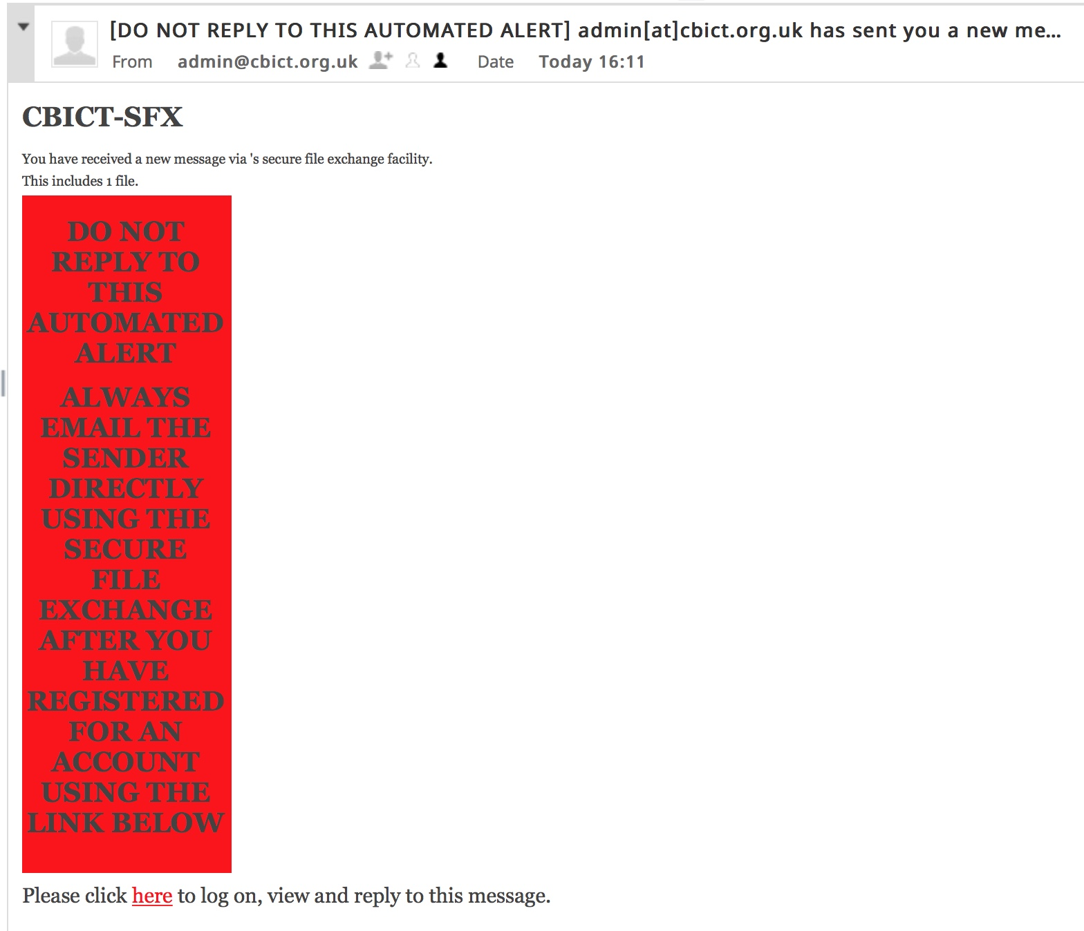

What happens if I forget my Password?
Simply click on the Forgot my Password link on the front page, you’ll then be asked to enter your email address and PIN. Click on the RESET button and you’ll be sent an email to your registered email address. The front page will display a message saying “We’ve now processed your password reset request and have sent you an email with further instructions”. The email will ask you to click on a link in the email which will take you back to the login page. A new message will now be displayed on the login screen saying “In order to change your password, simply enter your desired password twice and click on the reset button”.

